

Prepared by:

Noor Zehra 00118 12besenzehra@seecs.edu.pk

Zaryab Khan 01122 12besezkhan@ seecs.edu.pk

Ghania Riaz 01813 12besegriaz@ seecs.edu.pk

Atiqa Zafar 00024 12beseazafar@ seecs.edu.pk

Instructor: Sir Awais Shibli

Course: SE200 Software Engineering

Lab section: BESE 3B

Teaching Assistant: Mariam Amir & Farhan Humayun

Date: Monday, 30th December 2013

SDS TEMPLATE

Revisions

1 Introduction

1.1 Document Purpose

1.2 Product Scope

1.3 Intended Audience and Document Overview

1.4 Document Conventions

1.5 References and Acknowledgments

2 SYSTEM OVERVIEW

2.1 Product Perspective

2.2 Product Functionality

3 DESIGN CONSIDERATIONS

3.1 assumptions and dependencies

3.2 constraints

4 ARCHITECTURE

4.1 architecture Strategies

4.2 system architecture (4+1 view model)

4.2.1 logical view using class object diagram

4.2.2 process view using process diagrams, activity diagrams, state charts, sequence diagrams

4.2.3 development view using collaboration diagram

4.2.1 physical v iew

4.2.2 deployment diagram

4.3 database schema

4.3.1 entities

4.3.2 er diagram

Appendix A – Data Dictionary

Revisions

| **Version** | **Primary Author(s)** | **Description of Version** | **Date Completed** |
| --- | --- | --- | --- |
| 1.0 | Atiqa Zafar  Ghania Riaz  Noor Zehra  Zaryab Khan | This SDS Document contains the design considerations and constraints, the system architecture strategies and the design architecture itself for Vote Dou 1.0 implementation. | 30/12/13 |

# Introduction

Vote Dou 1.0 is an electronic voting system that will automate the process of casting a vote and counting votes. It is presented as an alternative to the existing parliamentary voting procedure present in Pakistan.

This section of the SDS contains the purpose of this document, the scope of the proposed electronic voting system, the intended audience of this document and the definitions of the terms coming in the afterward sections of this document.

## Document Purpose

The purpose of this SDS Document is to list down the software design specifications for Vote Dou 1.0 gathered through modelling of the electoral system using UML diagrams. These software design specifications include the architectural, interface and component-level design for the system. It also specifies the application domain, system boundaries and operational constraints to be considered in implementation phase.

This document, therefore, ensures that the team understands how services provided by the system should be implemented and under which operational constraints, the system will be designed and implemented. The information is organized in such a way that the developers will not only understand the boundaries within which they need to work, but also how functionality needs to be developed and in what order. This helps breaking the deliverables into smaller components and implementing the system. An added advantage of this document is that it may help the team understand the design process of the system being designed in the evolution and development of future versions of Vote Dou.

## Product Scope

In the present electoral system of Pakistan, the National Assembly is elected directly by the people of Pakistan. The Election Commission of Pakistan is a constitutionally established institution responsible for holding elections countrywide. Unfortunately, there hasn’t been a single election in Pakistan that has escaped the slogans of rigging and corruption. Moreover, the manual electoral system is time consuming and resource consuming. Printing ballots, buying ballot boxes and hiring staff increase the total cost. There is no proper and reliable database of result maintained either. All the records are saved in files, which can easily be misplaced. There is a dire need for automation of the system in order to make the election free and fair and remove doubts of possible rigging.

Vote Dou is an electronic voting system that is presented as an alternative to the existing parliamentary voting procedure present in Pakistan. Vote Dou is a project that could help the Pakistani electoral system get rid of corruption and rigging by replacing the ballot paper with a computer connected to the Vote Dou database that can record a voters vote and send the information over to the database.

## Intended Audience and Document Overview

The Intended Audience of this document will be the development team, the client and the Course Instructor Sir Awais Shibli who has assigned this project to the development team as their semester project of Software Engineering course.

As aforementioned, this document describe all data, architectural, interface and component-level design for Vote Dou 1.0. The document is structured into four sections and two appendices. The first section introduces the reader to the system and the use of the document. It specifies the purpose and the format of the document. It also mentions all the terms necessary to properly interpret the SDS.

The next section “SYSTEM OVERVIEW” describes the product perspective, functionality, major responsibilities and roles by mentioning how the system interact with the environment and how it is being used.

The third section “DESIGN CONSIDERATIONS” describes the assumptions and constraints imposed on design and implementation of the system.

The fourth section “ARCHITECTURE” provides a high-level overview of how the functionality and responsibilities are partitioned and then assigned to subsystems and components. The flow of information between subsystems is shown using different diagrams.

It includes a data dictionary and group log at the end as well.

This document must be read section-wise to grasp a better understanding of the proposed system.

## Definitions, Acronyms and Abbreviations

DBA Database Administrator

ECO Election Commission Officer

IEEE Institute of Electrical and Electronic Engineers

SRS Software Requirements Specifications

PA Provincial Assembly

NIC National Identity card

NA National Assembly

## Document formatting Conventions

This document uses the IEEE formatting requirements. It uses the font style Calibri and size 11 throughout the document. The text is single spaced and maintains the 1’’ margins. Every section and subsection name is bold-faced for clarity.

## References and Acknowledgments

Official Website: Election Commission of Pakistan [ecp.gov.pk/](http://ecp.gov.pk/)

Official website: Pakistan Elections 2012-2013 [elections.com.pk/](http://elections.com.pk/)

Wikipedia page: Election Commission of Pakistan [wikipedia.org/wiki/Election_Commission_of_Pakistan](http://en.wikipedia.org/wiki/Election_Commission_of_Pakistan)

# System Overview

## Product Perspective

Vote Dou is an electronic voting system that automates the existing parliamentary voting procedure of Pakistan. In the existing system, the National Assembly and the Provincial Assemblies are elected directly by the people of Pakistan. The Election Commission of Pakistan is a constitutionally established institution responsible for holding elections countrywide. The diagram below shows how the commission holds an election in the country.

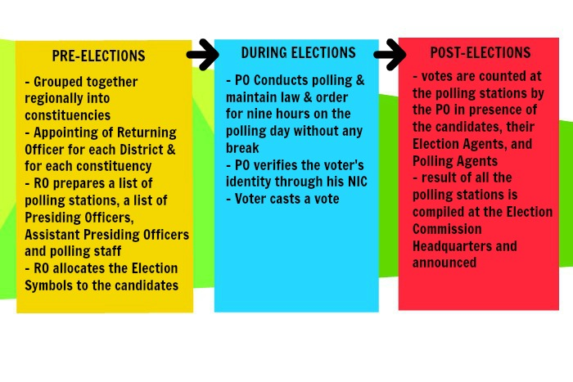

Unfortunately, there hasn’t been a single election in Pakistan that has escaped the slogans of rigging and corruption. The manual electoral system is further time consuming and resource consuming.



Vote Dou is a project that could help the Pakistani electoral system get rid of corruption and rigging by replacing the ballot paper with a computer connected to the Vote Dou database that can record a voter’s vote and send the information over to the database. The software not only helps cast electronic votes but it also helps to set up elections, manage constituencies, manage the candidates contesting on these constituencies and determine the results on the Election Day. Vote Dou is based on the idea that a computer integrated to the Vote Dou database will be set up at each polling booth where the voters will vote their candidates participating from their respective constituencies. The GUI will be user friendly allowing the uneducated voters to easily cast their votes too. The voters CNIC will be checked before their vote is casted and their thumb print taken too as a precaution. Once the voter enters the polling booth, they will log in to their account using the username (their CNIC number) and the password provided to them by the election officials. The polling continues on the Election Day in the time allocated for the election after which the polling stops and the election results are generated. The voters, election commission officers and database administrator will have different access rights defined according to their roles. The following diagram illustrates how the system interacts with its external environment and the way the system is put to use:

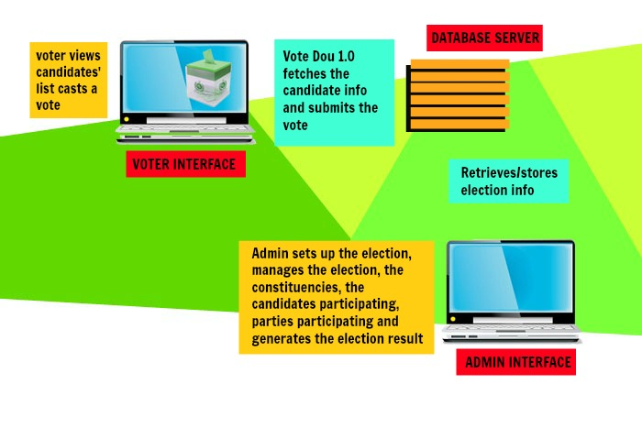

## Product Functionality

Vote Dou 1.0 provides a set of tools that allow voters to cast ballots while the election commission collects votes and outputs the final result. It performs the following functions:

* It implements a user access right policy through user identity authentication at login. Each user is provided with a username, a password and different access rights according to the roles of the Administrator, Election Commission Officer and the Voter.
* It provides the administrator with an easy-to-understand interface to manage elections. A new election session can be created or an existing one can be edited using an election ID. Information about the constituencies, candidates and voters can be inserted, edited and deleted.
* The Voter Interface runs on the electronic voting machines located at the polling stations and is used to cast a vote by the voter.
* It provides the Election Commission officer with a user-friendly interface to view the election information and compute the results. The officer can filter the results by Constituency or Party Name and generate a report to announce results.
* The administrator can create a backup of an election session and store all the information about the contesting candidates, voters, constituency results and final results.

The Diagram of the system shows how the election shall proceed with Vote Dou and how the above mentioned functions relate to each other.

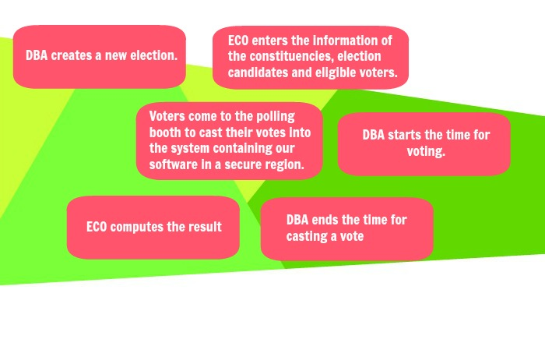

# Design Considerations

## Assumptions & Dependencies

- It is assumed that NADRA shall provide the DBA with all the required information about the candidates and voters.

- It is expected that NADRA will provide the thumb prints of all the candidates who are eligible to vote.

- It is assumed that the Election Commission of Pakistan will place a computer at every Polling booth.

- It is assumed that the Polling booths shall be guarded with security personnel that would prevent any external threats from disrupting the process of voting.

- It is assumed that Election Commission of Pakistan will recruit ECO’s who have know-how of the system. And it will be arrange orientation programs for newly recruited officers to help them understand the new system. The development team will provide an ECO Manual along with the product delivery.

- The size of data will continually be changing as new voters are added to the system so the data holding capacity of the server will be required to increase after a certain amount of time.

- Vote Dou will function only on Windows and is not compatible with other operating systems.

- Vote Dou provides a user friendly interface and it can also be operated the uneducated people. The process of casting a vote has been simplified as compared to the current system of casting a vote that is present in the nationwide general elections.

## General Constraints

* Although the software provides a user friendly GUI, the voters using the software will be alien to it as voting electronically will be a new experience for most of the voters. The frequency of voters making an error while casting the vote may be higher than expected.
* The software should be operated on the reputedly robust systems available in the market to prevent any unexpected events on the polling day.
* It is expected that the developers of VOTE DOU will follow the ACM/IEEE code of ethics while developing the product.
* The security of the system and communication standards between the server and clients should be ISO certified.
* It is recommended that the systems designated for casting the votes should have uninterrupted internet access on the day of voting.
* The server shall have sufficient data capacity to easily handle the relevant data of all the voters.
* The project is based on the use of an oracle database. The server will be connected to the oracle database and all the data will be stored on it. The clients will connect to oracle database and the clients will fetch data from the oracle database via queries. Oracle Net enables connections from traditional client/server applications to Oracle Database servers.

# Architecture

## Architecture Strategies

The following Architecture strategies and design decisions provide an insight into the key abstractions and mechanisms used in the system architecture. Each of these affect the overall organization of the Vote Dou 1.0 system and its higher-level structures.

* Vote Dou 1.0 will be implemented using C# Windows Forms at the frontend and SQL at the backend. The Frontend is to be developed as a Windows form Application in C# programming language using Microsoft Visual Studio 2013 and is compatible with the Windows Operating System. At backend, a database consisting of relations, views and sequences will store all the data. It is to be created in the Microsoft Server Management Studio 2012. This database is to be linked as a data source with the Windows Application developed in Visual Studio.
* The Vote Dou software will be distributed over a network of clients connected to a central computer, known as a server where the database shall reside. The database administrator, election commission officer and the voter will login to the system from different locations and all of the users will be accessing the database concurrently. The SQL Server shall handle the concurrent requests of several users into the database effectively.

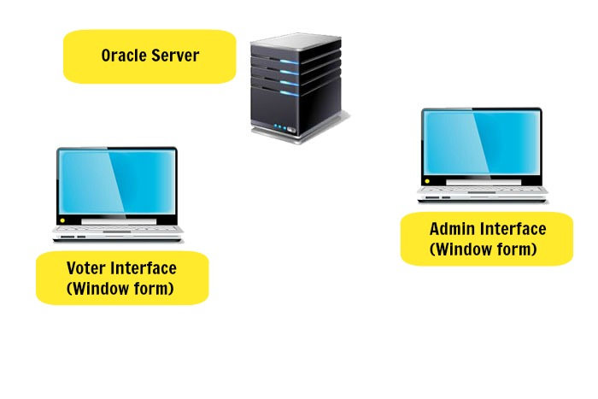

* Vote Dou 1.0 is to be composed of a number of hardware interfaces. At the polling stations, the Voter interface of the system is run on a computer with 300mb of hard disk space, 1 GB ram, and a dual core 1 GHz processor. It must be accompanied by a Visual Display Screen, a typing device (i.e. Keyboard) and a pointing device (i.e. mouse or digital pen). At the Election Stations, the Administrator/ECO Interface of the system is run on a computer.
* Logging in to the Vote Dou software shall require user identity authentication. The system should be password protected with utmost care being taken by the ECO, ensuring that the passwords are provided only to the required individuals. As an improvement to the user identity authentication process, Fingerprint of the users can be scanned to log in to the system. The scanned finger prints is matched against the finger print of the specific individual stored in the NADRA database. A scanning device is needed to acquire the finger print and will be connected to the voting terminal that’s runs Vote Dou.
* Error detection and recovery :

1. Vote Dou emphasizes on the need of a free and fair election. If it is found that there has been damage/theft of the Vote Dou system set up at the polling booth or if it is found that there has been a malicious intrusion into the database, the administrator will put the voting to a halt in the required region, whether it means stopping the voting process in a specific constituency or halting the entire election.
2. If there is an unexpected cut off in the power supply, the current processes will be put to a halt and all the pending the transactions will be rolled back to make sure there is no corruption in data or unexpected manipulation of values.
3. If the database is hacked, confidential information about the voter can be leaked or fake votes can be casted. Hence, Preventive measures should be taken to ensure that hacking into the Vote Dou database is impossible.

* Security considerations: Vote Dou shall not allow i-voting. I-voting is voting from one's personal computer, mobile phone, television via the internet. As i-voting doesn’t ensure the validity of a person’s vote, the Vote Dou software shall not provide the facility of online voting. Polling booth shall be guarded with security personnel that would prevent any external threats from disrupting the process of voting.
* Hardware limitations: Vote Dou 1.0 is a working prototype implementation of the actual e-voting system. Presently, it cannot avail the finger print user authentication procedure to secure user logins due to unavailability of scanners. In the future versions, the development team can either utilize the scanning devices already available in the market or write a program to scan and match a picture captured using a digital camera.

## System Architecture

In the following pages, the 4+1 view Architecture model is used to give an understanding of how and why the Vote Dou system is to be decomposed, and how the individual parts work together to provide the desired functionality. It separates the different aspects of a software system into different views of the system as follows:

* + 1. **LOGICAL VIEW**

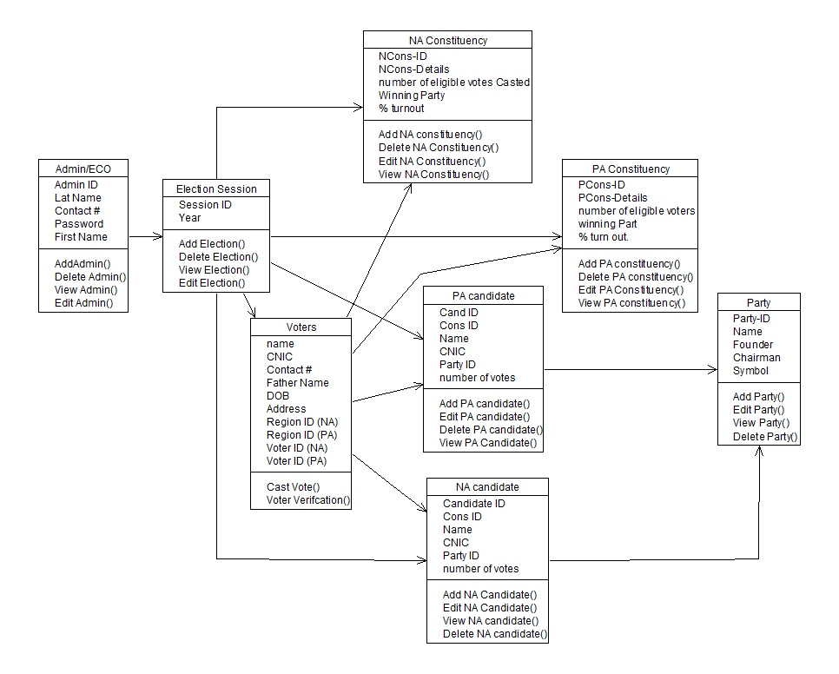The logical view of the Vote Dou 1.0 I is modelled using the following class diagram to show the key abstractions in the system.

* + 1. **PROCESS VIEW**

The process view of the Vote Dou 1.0 I is modelled using process diagrams, activity diagrams, state charts and sequence diagrams to show how, at run-time, the system is composed of interacting processes.

ACTIVITY DIAGRAM:

PRE-ELECTION

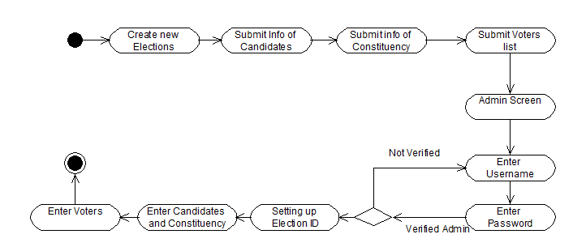

VOTING

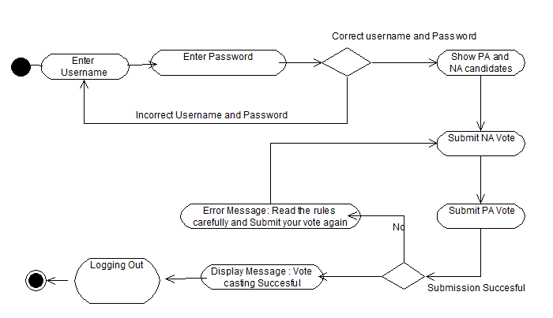

POST ELECTION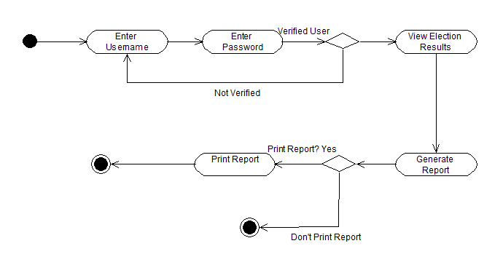

STATE CHARTS:

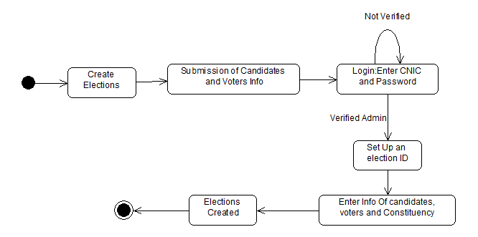PRE-ELECTION

VOTING

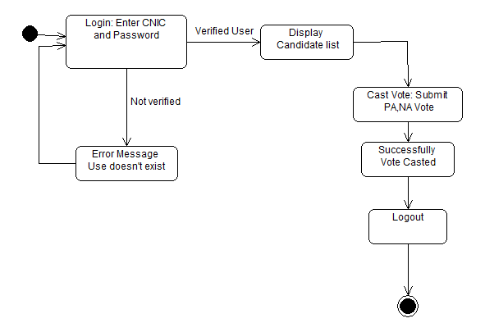

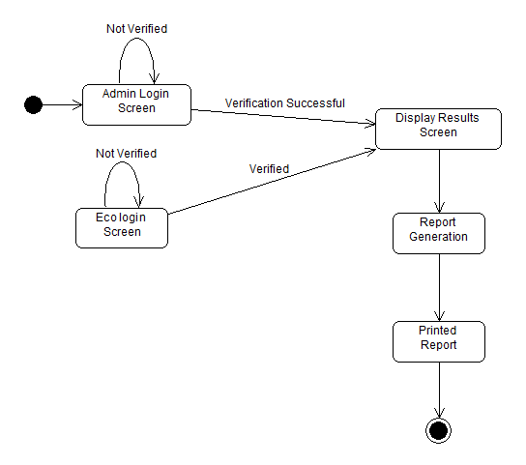POST-ELECTION

SEQUENCE DIAGRAM:

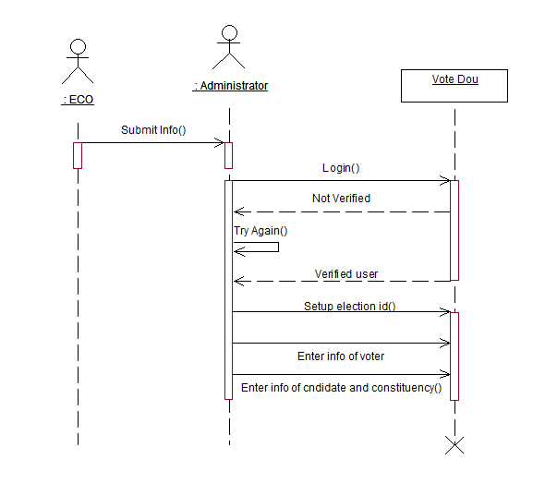SETTING UP ELECTION

VOTING

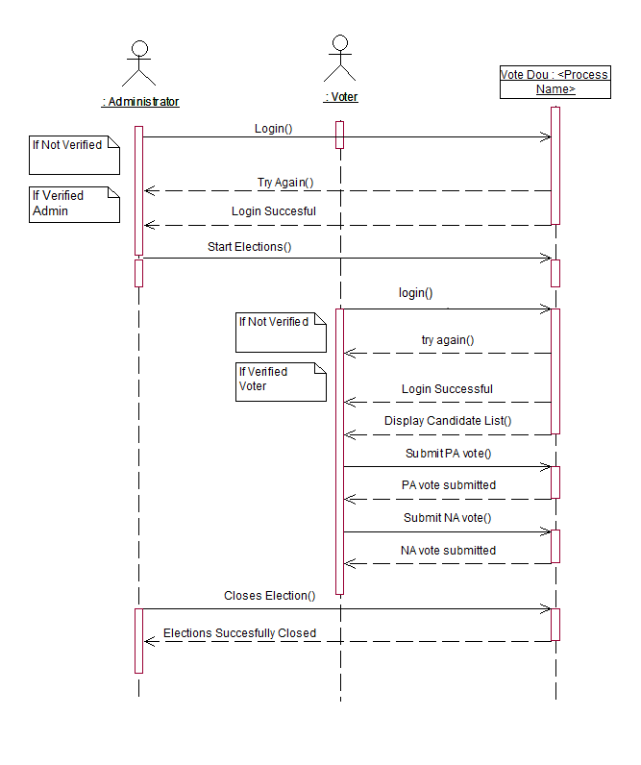

COMPUTING THE RESULTS

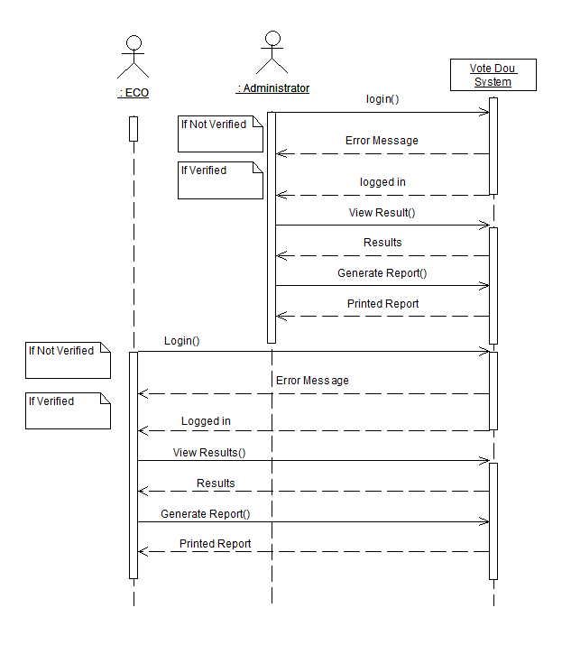

* + 1. **DEVELOPMENT VIEW**

The development view of the Vote Dou 1.0 I is modelled using component diagrams to show how the software is decomposed for development.

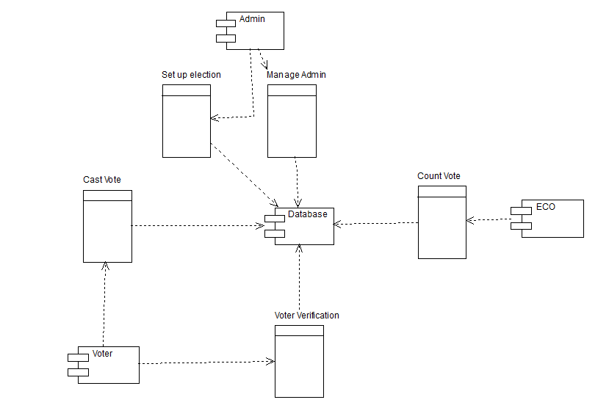

* + 1. **PHYSICAL VIEW**

The physical view of the Vote Dou 1.0 I is modelled using a deployment diagram and an architecture model to show the system hardware and how software components are distributed across the processors in the system.

**Deployment Diagram:**

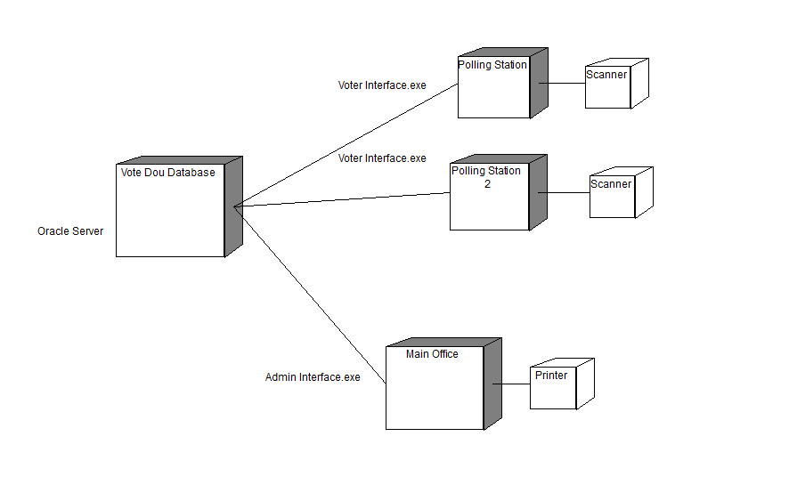

**Client Server Architecture Model:**

* The Vote Dou software will be distributed over a network of clients connected to a central computer, known as a server where the database shall reside. The database administrator, election commission officer and the voter will login to the system from different locations and all of the users will be accessing the database concurrently. The SQL Server shall handle the concurrent requests of several users into the database effectively.

Candidates (client)

Voters (client)

Vote Dou System (server)

Data Bases

Admin

* + 1. **USE CASE VIEW**

This view describes the functionality of the system from the perspective from outside world. It contains diagrams describing what the system is supposed to do from a black box perspective. The following use case diagram encapsulates the entire system and all possible actors. Each of these use cases have been defined in the SRS document.

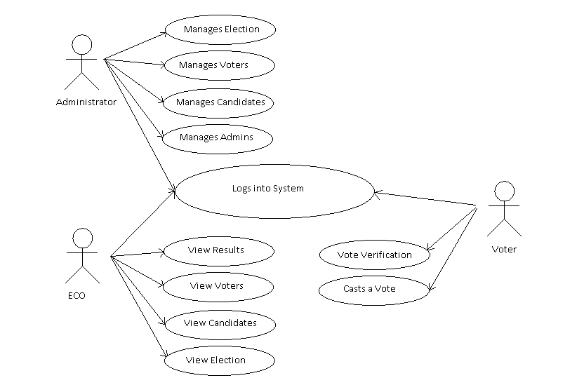

## Database Schema

Following are all the relations and attributes in our schema. An ER diagram is given to show relationships between the entities in our schema.

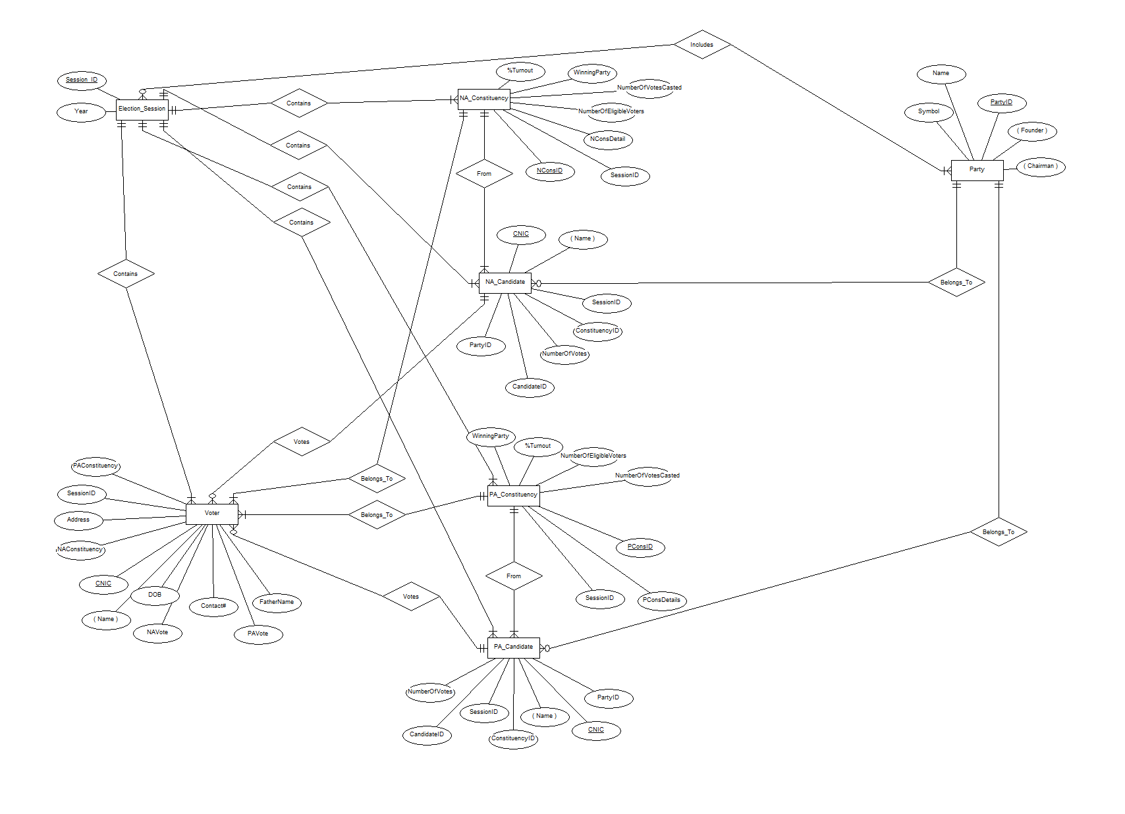

Entity: Administrator

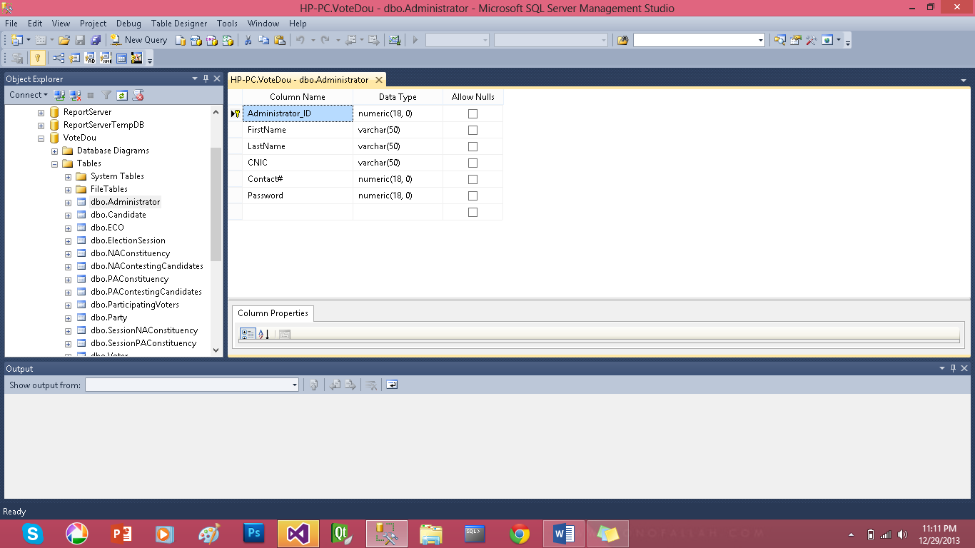

Entity: ECO

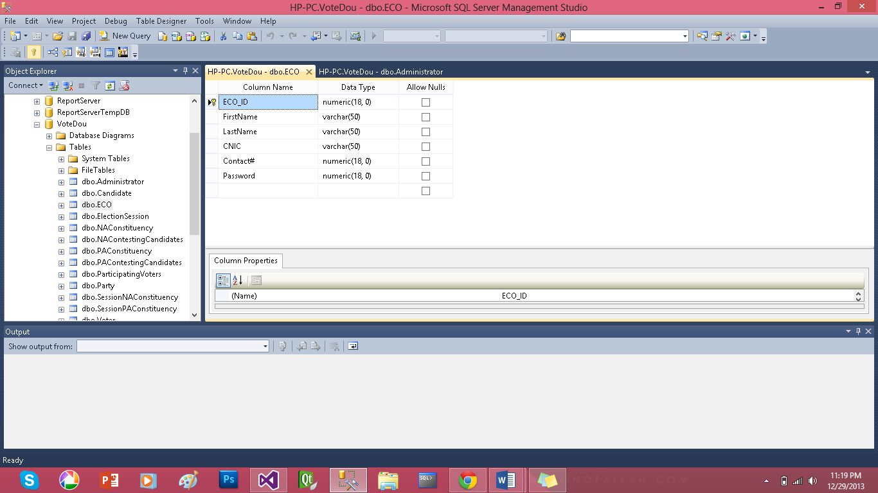

Entity: Election Session

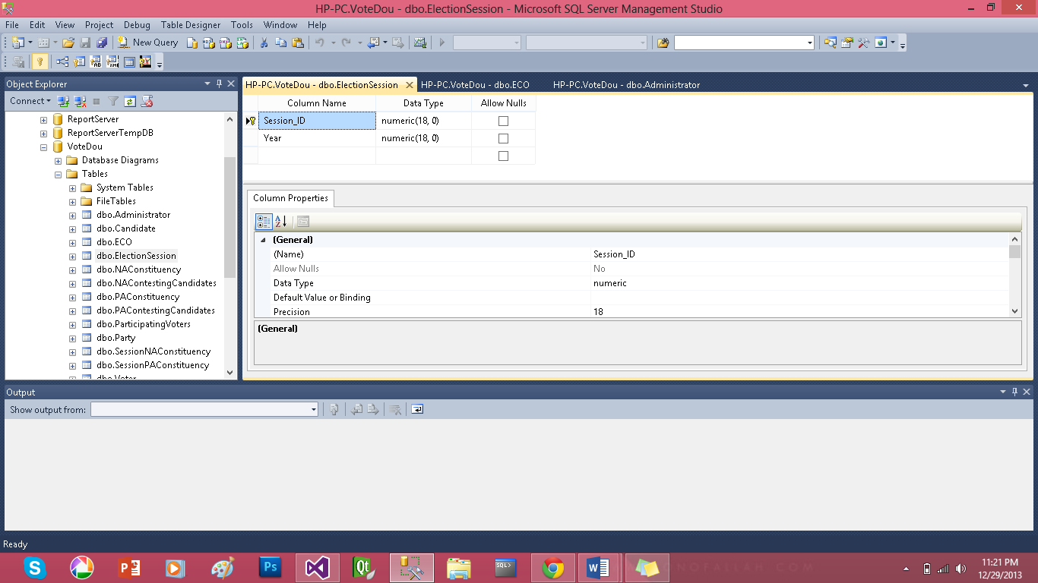

Entity: NA Constituency

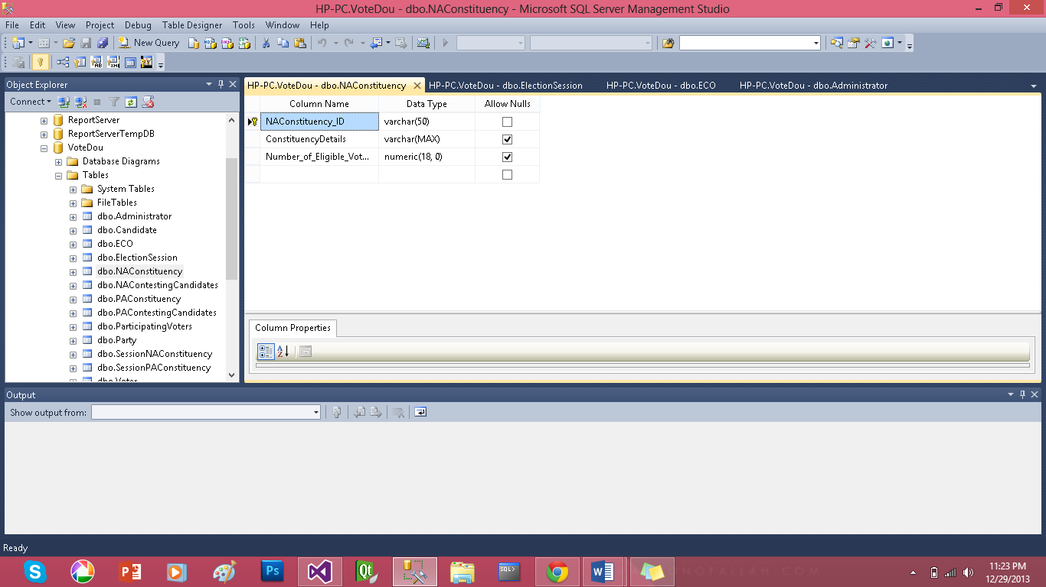

Entity: PA Constituency

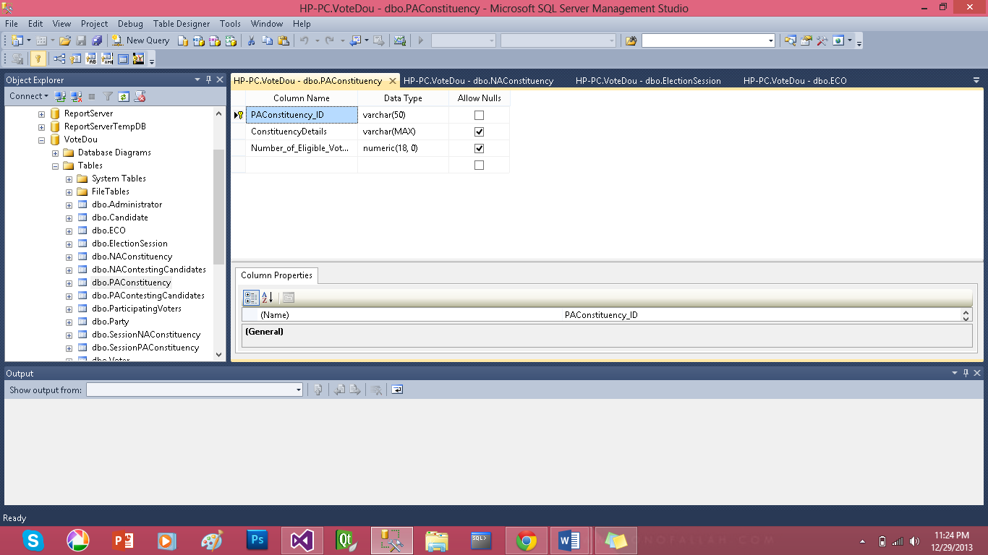

Entity: Candidate

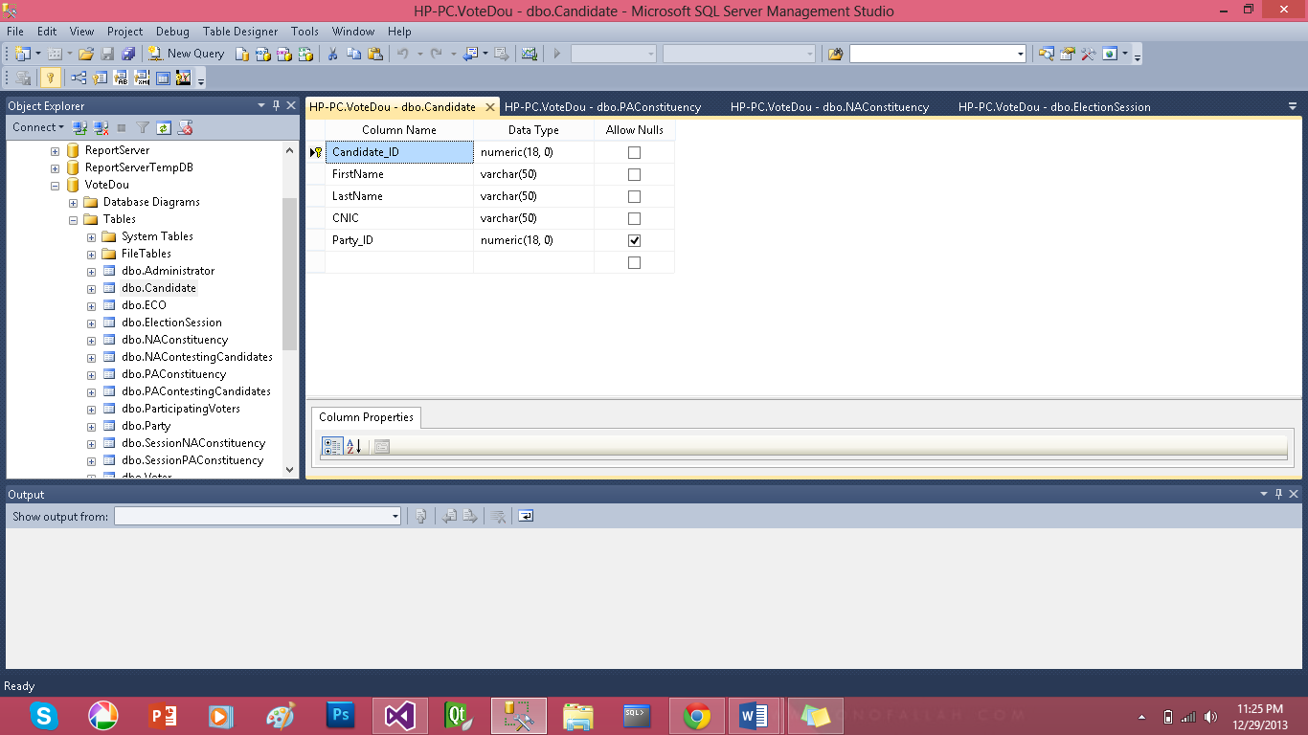

Entity: NA Candidate

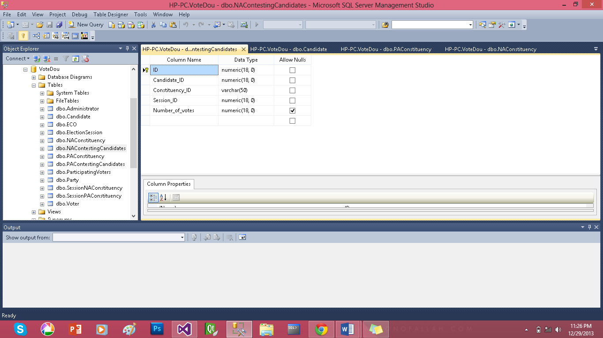

Entity: PA Candidate

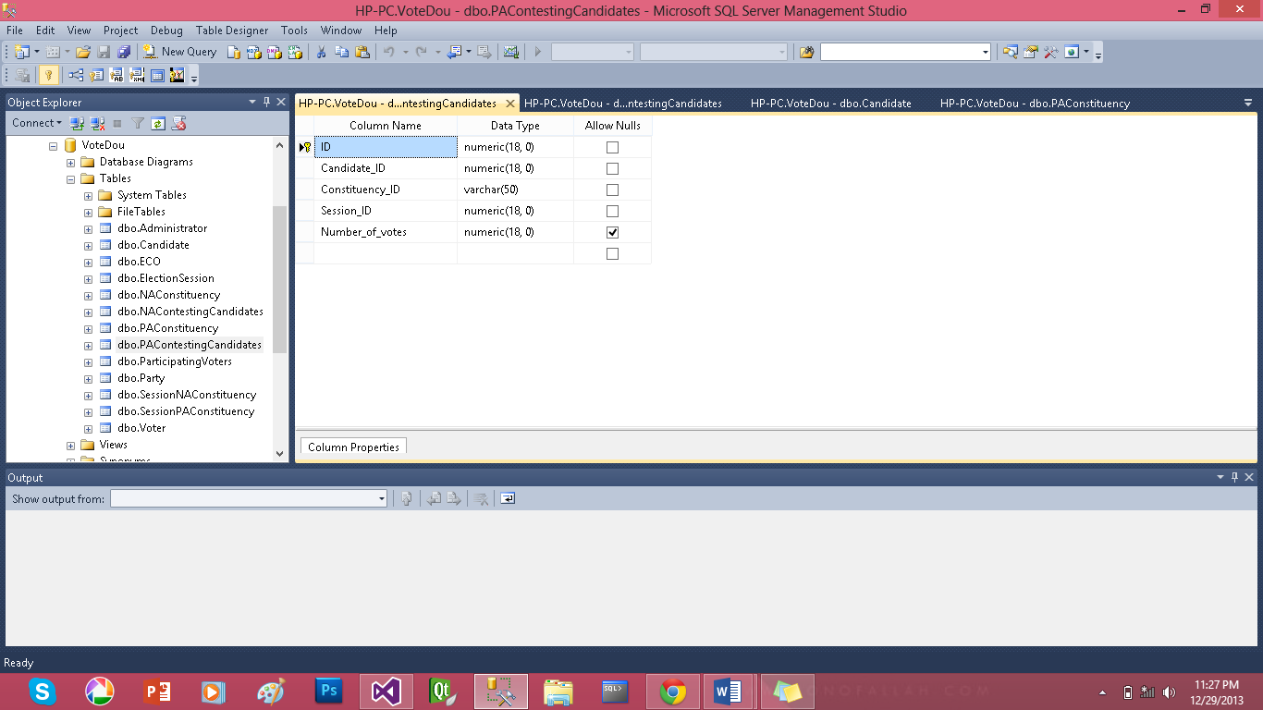

Entity: Voter

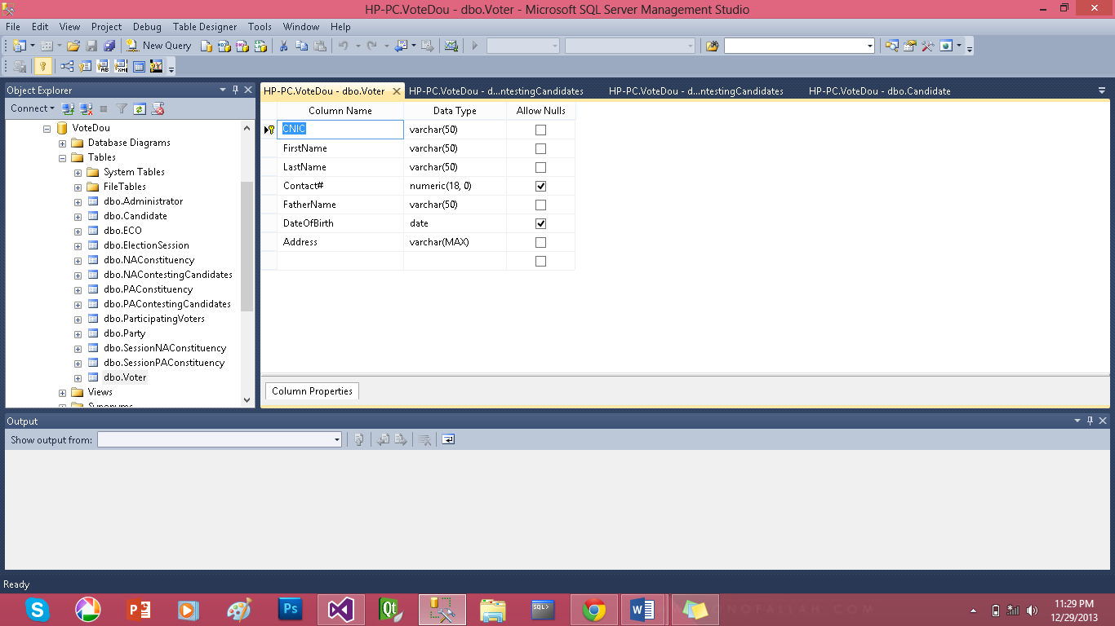

Entity: Participating Voter

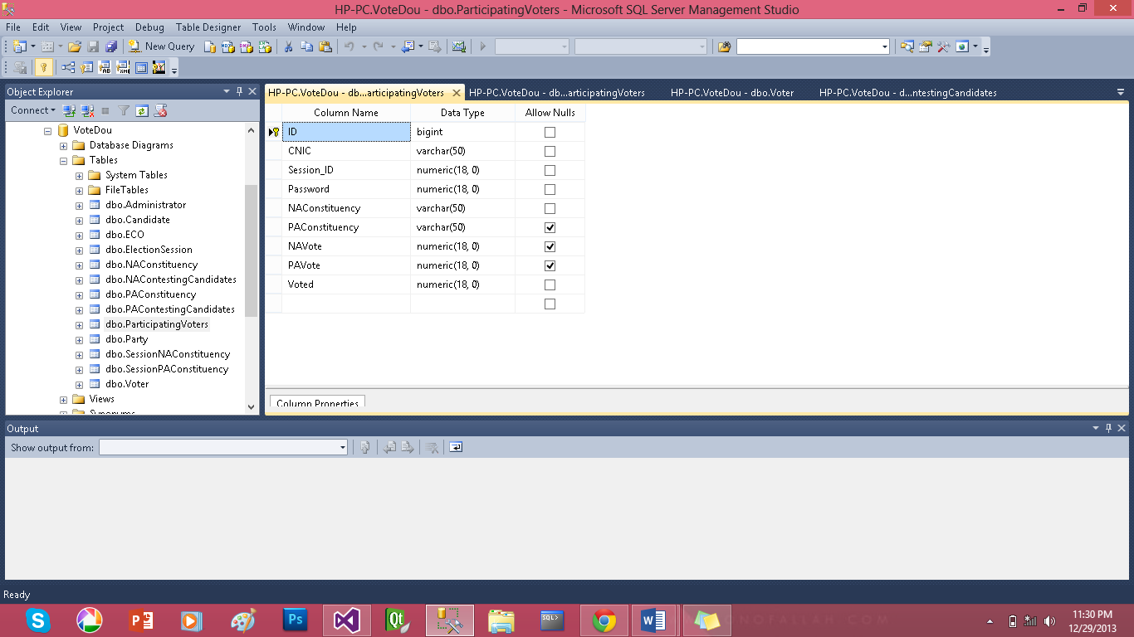

Entity: Party

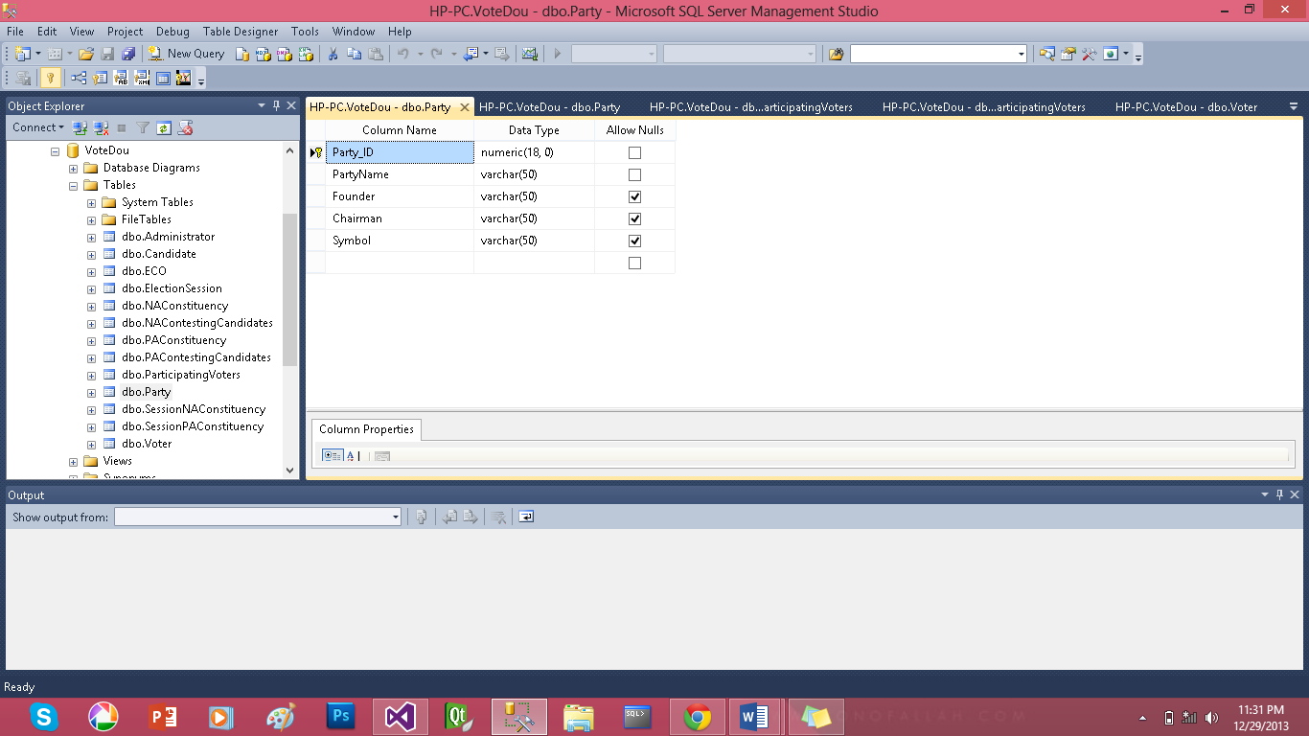

Appendix A – Data Dictionary

|  |  |
| --- | --- |
| E-voting | E-voting is an electronic voting system that encompasses both electronic means of casting a vote and electronic means of counting votes |
| I-voting | I-voting is voting from one's personal computer, mobile phone, television via the internet. |
| DBMS | Database Management system |
| DBA | Database Administrator |
| OS | Operating system |
| ECO | Election Commission officer |
| IEEE | Institute of Electrical and Electronic Engineers |
| SQL | Structured Query language |
| C# | C sharp is a [multi-paradigm programming language](http://en.wikipedia.org/wiki/Multi-paradigm_programming_language). |
| PA | Provincial Assembly |
| NA | National Assembly |
| Constituency | A region |
| Interface | Medium between two environments |
| Constraint | a limitation or restriction. |